ADVANCED Bikes UK look to extend their dealer network in the UK with the launch of RECO at Eurobike 22.

RECO frames are made of plastic granulate and recycled carbon fibre from the automotive industry and the frames are 100% recyclable!

ADVANCED have created a revolution in e-bike manufacturing with its RECO technology, which was recently given several prestigious awards, among which was the Design and Innovation Award 2022: https://design-innovation-award.com/winner/advanced-reco-one/

The RECO has also been entered into the Innovators Award Category for the Eurobike Awards 2022...fingers crossed!

Made out of a carbon fibre-reinforced plastic granulate with a complex injection moulding technology creating an extremely robust recyclable material. This method means that the frame can be ground up again after its life cycle, melted down and then manufactured into a new frame or component...making new from old material in a completely sustainable process.

This manufacturing process takes place over a short period of time and is energy- efficient without long transport routes, with the production of the RECO frames taking
place in Germany, with cost efficient and carbon neutral shipping to the UK.

Helge von Fugler, founder of ADVANCED in Germany describes more about this unique process... "The granulate used for new frames consists of recycled carbon fibre from the automotive industry. We can save 68% CO2 compared to a frame made of aluminium or a frame made of new layered carbon fibre. The great thing about RECO is that the process actually exists and is proven with bikes on the road, it is not a product study or concept...RECO One e-bikes are already being used by riders. According to Helge, the production of bicycles with the RECO technology is to be significantly expanded onto all models in the next few years, with ADVANCED leading the way in sustainability within global bike manufacture.

Making sustainable e-bikes starts in the production...90% of bicycle frames are produced in Asia using very energy-intensive processes. They travel long distances to end up back in Asia after their lifetime. Injection-moulded RECO frames are manufactured quickly and energy-efficiently in Germany. The production of frames is both swift and flexible meaning that both dealers and consumers benefit from this new innovation.
This process makes sustainable e-bikes accessible to a large market and at the same time protects the environment and resources.

The frame is just the beginning...
A circular economy is a key Ethos at ADVANCED. An e-bike consists of many individual components from different manufacturers.

The team at ADVANCED will also be looking at other durable bicycle components, such as mudguards, luggage racks, rims, spokes, seatposts, stems and handlebars, to be
made from their composite material. The more parts ADVANCED produce themselves from the recycled material, the greater our control over the material cycle when it comes to speccing and building our range options.

The RECO range features include...

Bosch Smart System,
CX Motors 85 Nm torque
500, 625, 750 Wh batteries
Hub or derailleur gearing
Chain or belt drive
Wave or diamond frames
Rigid or suspension fork
2 sizes: S-M, L-XL
3 colour options. 2 Gloss , 1 Matte.
Active, comfortable riding position
48 different SKUs
30 year frame warranty
4 year Bosch system warranty

RRP £4,549, £4,749

UK and ROI Distributors, Adam and Sophie Browne from Advanced Bikes UK commented…

"It's amazing to launch the RECO range at Eurobike and we look forward to welcoming many UK dealers and press to our stand at the event. The RECO range of e-bikes offers high quality build and spec options, top of the range technology, a great aesthetic and competitive pricing...all with an inspiring sustainability message. RECO will be available in the UK from Autumn 22 and we are taking orders now. The feedback from dealers and press who have seen the early samples has been awesome and we look forward to extending our network in the UK. Working with our partners in Germany we have created a range of bikes that offer excellent performance and styling, while at the same time promote sustainability. We are passionate about cycling advocacy and providing e-bikes that offer solutions to many modern issues, including transport, health and the environment. Swing by the stand to see the range and test one of the RECO e-bikes at the Eurobike demo facility”.

To find out more about these innovative e-bikes and the bespoke process behind their manufacture please visit stand A04 in Hall 4 and in the Open Air Ground F.12 I10 at Eurobike.

Sophie Browne
Director & Co-Founder
+447552482967

www.advancedbikes.uk

https://www.facebook.com/advancedbikes.uk

https://www.instagram.com/advancedbikes.uk/

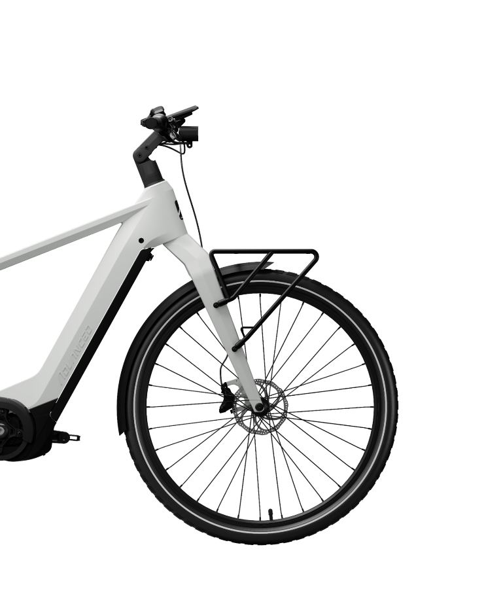
www.linkedin.com/company/advancedbikesuk
